Signals and Systems

UE18EC204

Assignment No:1

Group Members:

1.Abhirath Koushik-PES1201800632

2.Rutwik Ganagi-PES1201800627

3.Shivang Mishra- PES1201800554

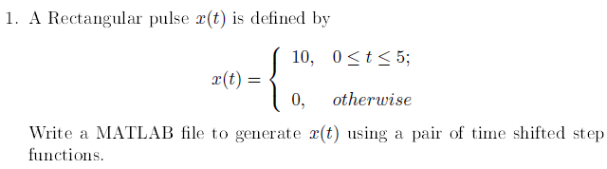Unit-1

MATLAB CODE:

t=(-10:0.01:10)';

unitstep= t>=0;

unitstep1= t>=5;

plot(t,unitstep-unitstep1);

xlabel('t');ylabel('u(t)');

title('Q-1:Time Shifted Step Function');

GRAPHS:

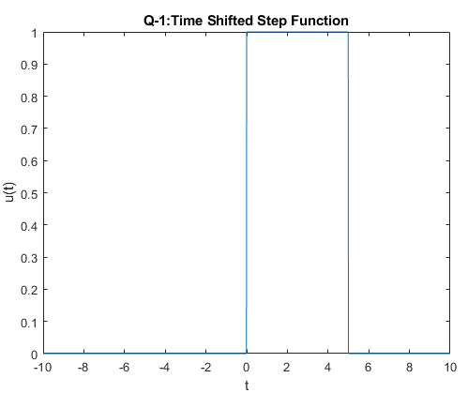

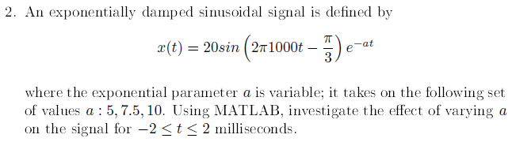

MATLAB CODE:

t1=-2:0.001:2;

a=5;

y=20\*sin(2\*pi\*10\*t-pi/3).\*exp(-a\*t);

plot(t1,y);

title("When a=5");

a=7.5;

y=20\*sin(2\*pi\*10\*t-pi/3).\*exp(-a\*t);

plot(t1,y);

title("When a=7.5");

a=10;

y=20\*sin(2\*pi\*10\*t-pi/3).\*exp(-a\*t);

plot(t1,y);

title("When a=10");

GRAPHS:

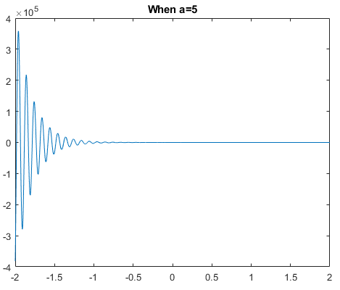

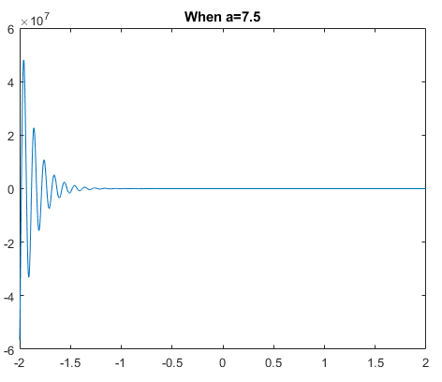

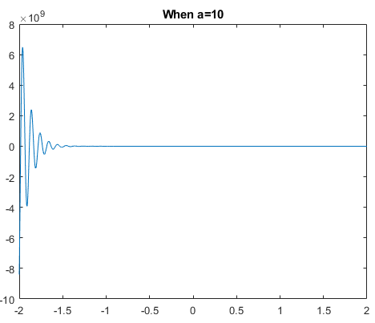

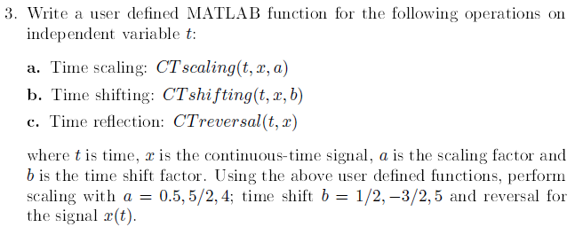

MATLAB CODE:

%Part 'a', Time Scaling

t1=-2:0.001:2;

y=sin(t1);

plot(t1,y);

title("Original Signal");

a=0.5;

timescale(t1,y,a);

title("Expanding by 0.5");

a=2.5;

timescale(t1,y,a);

title("Compressing by 2.5");

a=4;

timescale(t1,y,a);

title("Compressing by 4");

%Part 'b', Time Shifting

t2=-2:0.001:2;

x=sin(t2);

plot(t2,x);

title("Original Signal");

b=0.5;

timeshift(t2,x,b);

title("Delayed by 0.5");

b=-1.5;

timeshift(t2,x,b);

title("Advanced by 1.5");

b=5;

timeshift(t2,x,b);

title("Delayed by 5");

%Part 'c', Time Reversal

rev=-y;

plot(t1,rev);

title("Time Reversal");

function timeshift(t2,x,b)

x=sin(t2+b);

plot(t2,x);

end

function timescale(t1,y,a)

y=sin(a\*t1);

plot(t1,y);

end

GRAPHS:

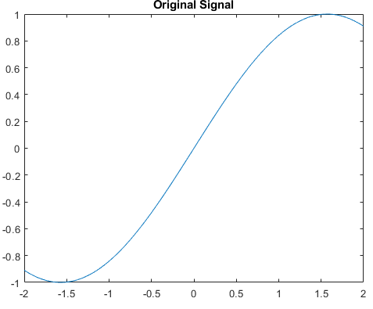

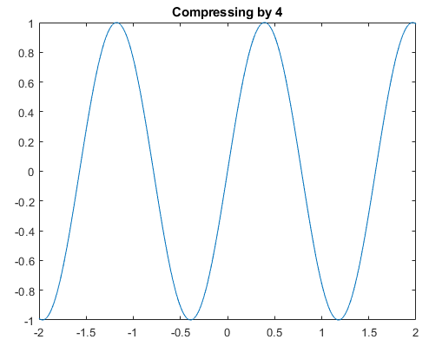

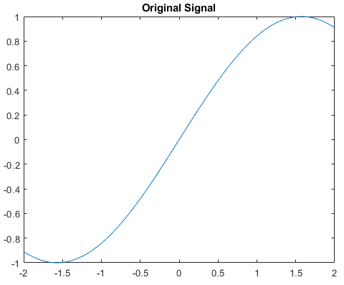

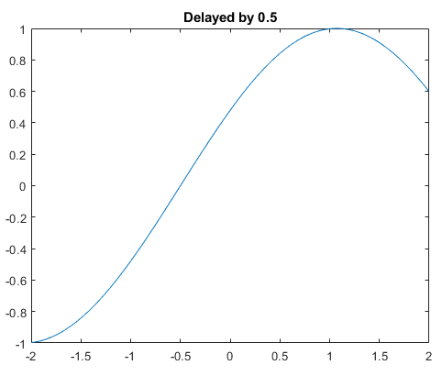

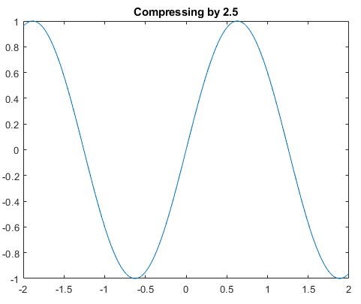

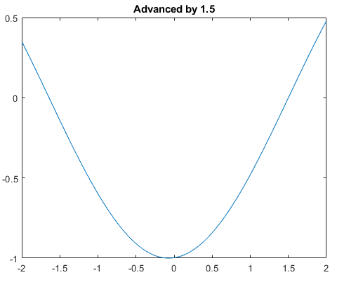

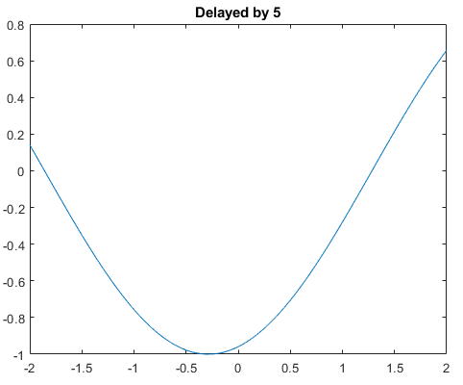

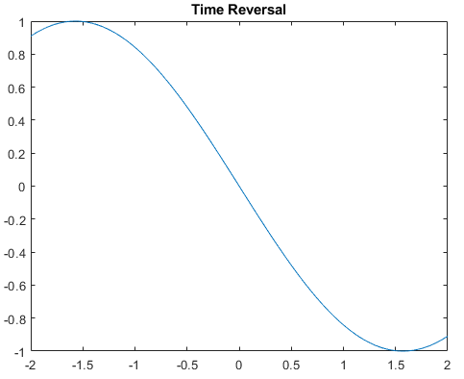

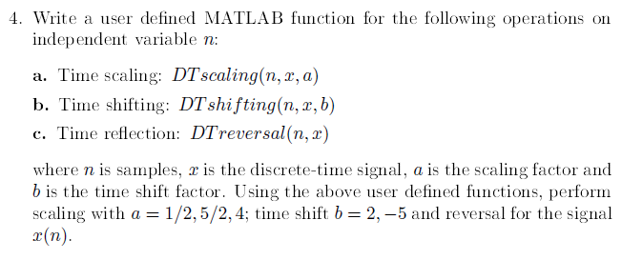

MATLAB CODE:

%Part a Time scaling

n=0:10;

y=[n];

stem(n,y);

title("original signal");

a=0.5;

timescale(n,y,a);

title("Expanding by 0.5");

a=2.5;

timescale(n,y,a);

title("Compressing by 2.5");

a=4;

timescale(n,y,a);

title("Compressing by 4");

%Part b,time shifting

n2=0:10;

x=[n2];

stem(n2,x);

title("original signal");

b=2;

timeshift(n2,x,b);

title("delayed by 2");

b=-5

timeshift(n2,x,b);

title("advanced by 5");

%part c,time reversal

rev=-y

stem(n,rev);

title("time reversal");

function timeshift(n2,x,b)

x=(n2+b);

stem(n2,x);

end

function timescale(n,y,a)

y=(a\*n);

stem(n,y);

end

GRAPHS:

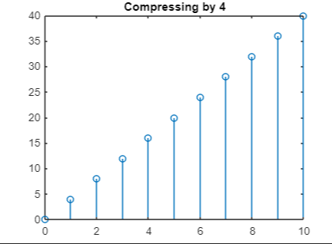

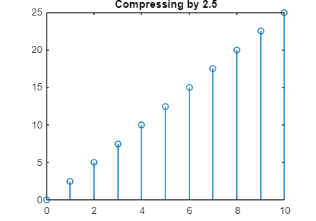

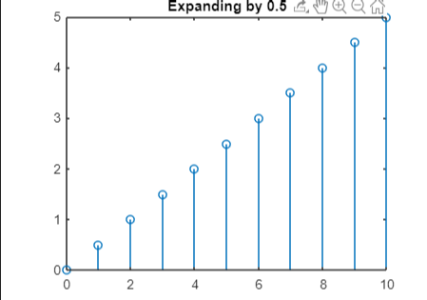

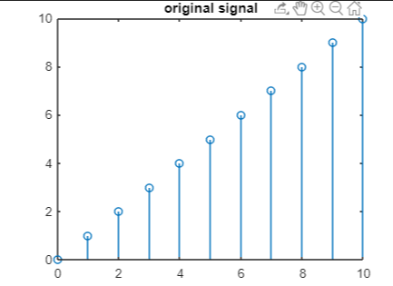

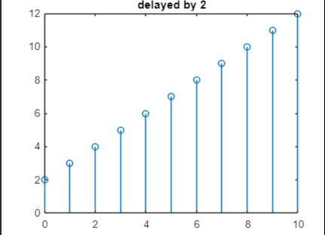

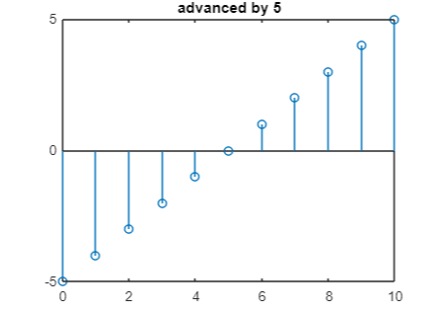

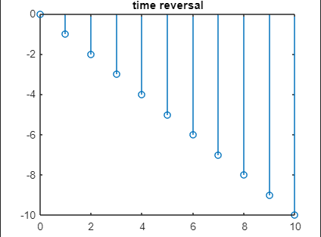

Unit-2

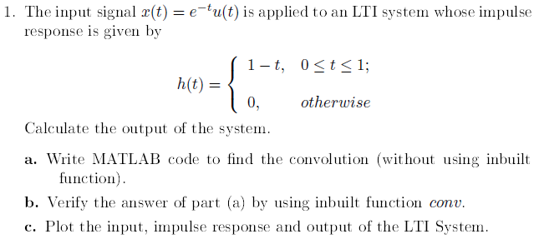

MATLAB CODE:

clc;

t=linspace(0,8,16384);

ind=t>=0 & t<=8;

x(ind)=exp(-2\*t(ind));

figure;

plot(t,x,'linewidth',2);

ylim([0,1.5]);

grid on;

xlabel('t');

ylabel('x(t)');

title('x(t)');

t=linspace(0,6,16384);

ind=t>=0 & t<=1;

h(ind)=1-t(ind);

ind=t>1 & t<=6;

h(ind)=0;

figure;

plot(t,h,'linewidth',2);

ylim([0,3]);

grid on;

xlabel('t');

ylabel('h(t)');

title('h(t)');

z=median(diff(t))\*conv(x,h,'same');

figure;

plot(t,z,'linewidth',3);

xlabel('t');

ylabel('y(t)');

title('Convolved graph');

hold on;

GRAPHS:

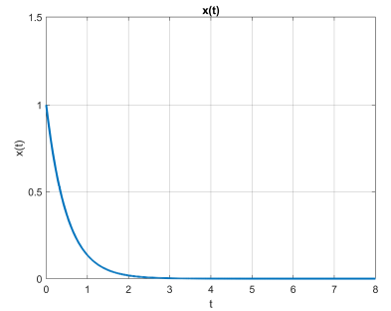

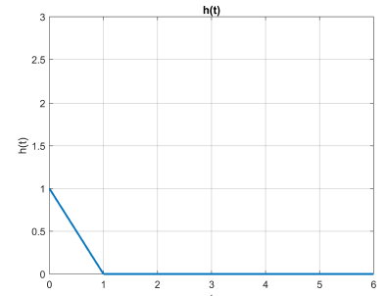

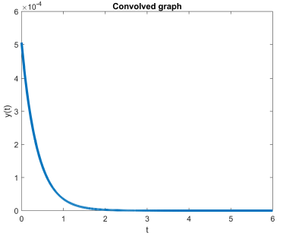

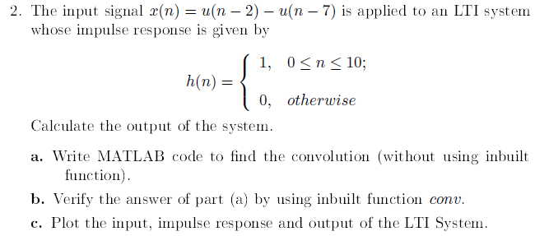

MATLAB CODE:

t1=[0:1:2];

t2=[2:1:7];

t3=[7:1:9];

a=[t1 t2 t3];

x=[zeros(size(t1)) ones(size(t2)) zeros(size(t3))];

stem(a,x);

disp(a);

xlabel('n');

ylabel('x(n)');

axis([-1 10 0 2]);

ta1=[-2:7:0];

ta2=[0:1:10];

ta3=[10:1:12];

a1=[ta1 ta2 ta3];

h=[zeros(size(ta1)) ones(size(ta2)) zeros(size(ta3))];

stem(a1,h);

xlabel('n');

ylabel('h(n)');

axis([-2 12 0 2]);

m=length(x);

n=length(h);

X=[x,zeros(1,n)];

H=[h,zeros(1,m)];

stem(conv(x,h));

for i=1:n+m-1

Y(i)=0;

for j=1:m

if(i-j+1>0)

Y(i)=Y(i)+X(j)\*H(i-j+1);

else

end

end

end

% plot results

figure;

stem(Y);

ylabel('Y[n]');

xlabel('n');

grid on;

title("Convolution of two signals without conv function");

GRAPHS:

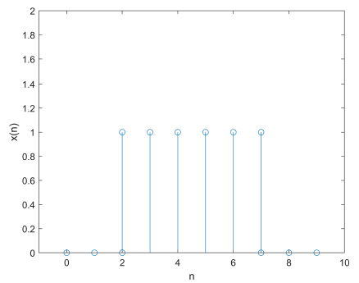

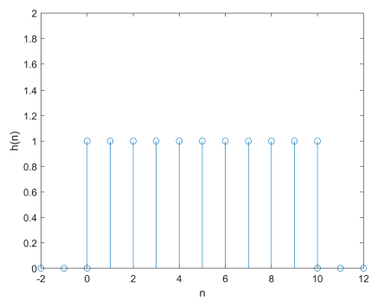

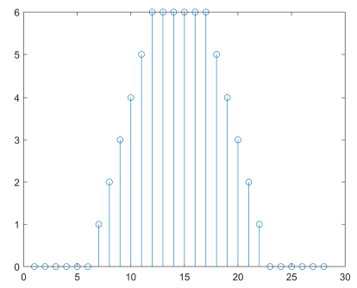

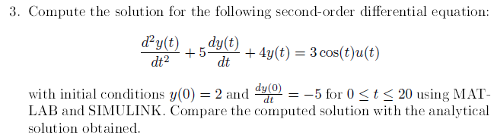

MATLAB CODE:

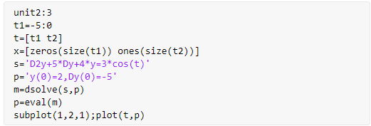

GRAPHS:

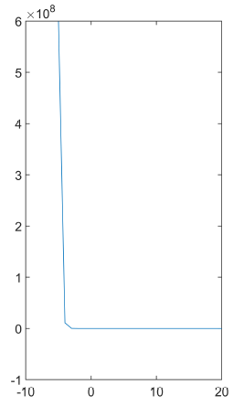

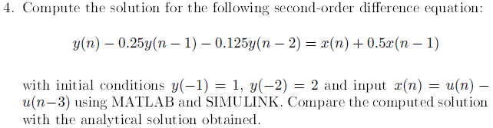

MATLAB CODE:

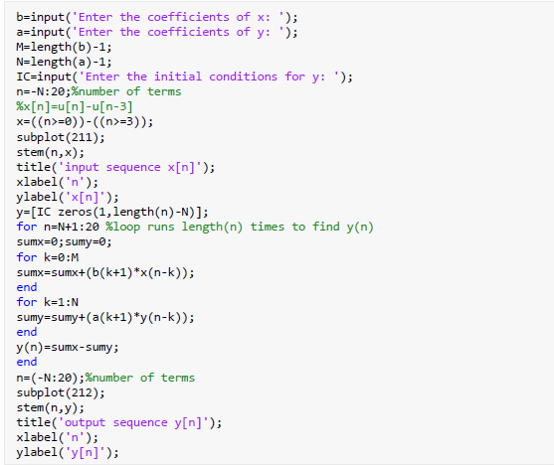

GRAPHS: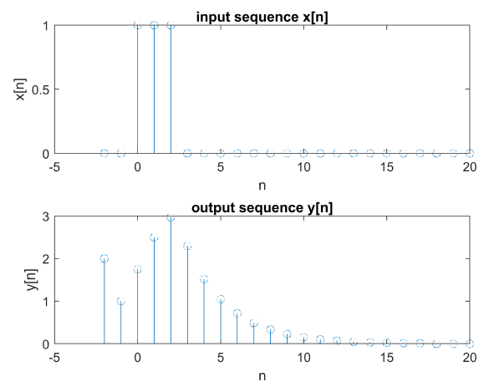



MATLAB CODE:

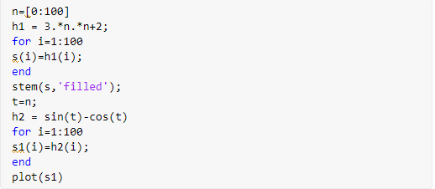

GRAPHS:

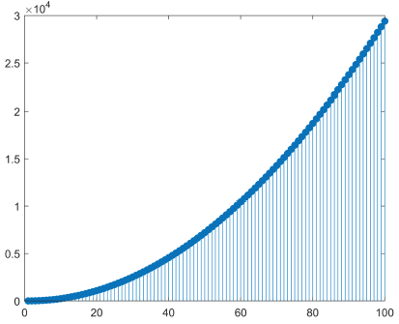

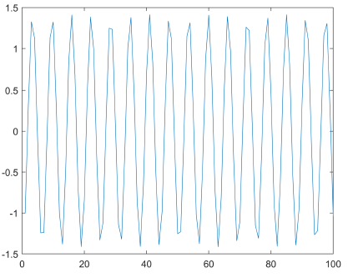



MATLAB CODE:

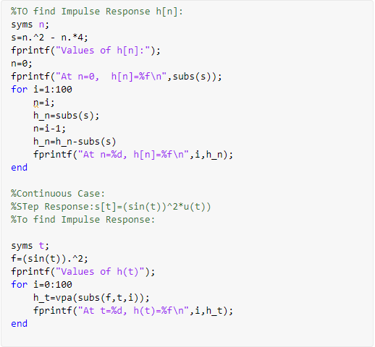

OUTPUTS:

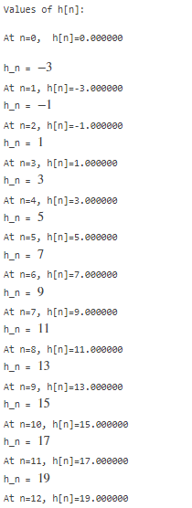

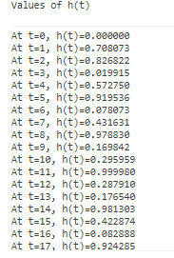

GRAPHS:

